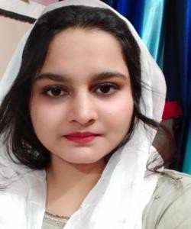Resume

**Karira Tarannum**

Contact No.:06388521934

Add: Dasauli Near Integral University Kursi Road Lucknow Pin-226026 Email: [kariratarannum5@gmail.com](mailto:kariratarannum5@gmail.com)



Career Objective:

To succeed in an environment of growth and excellence and earn a job which provide me

job satisfaction and self development and help me to achieve personal as well as organizational goals.



# Summary Skills:

* Writing
* Problems Solving
* Collaboration
* Social Media
* Enterprise software
* Analytical skills



# Qualification:

* Diploma
* High School



# Professional Credentials:

* Pursuing B.Tech Computer Science Engineering from Integral University Lucknow



# Computer Proficiency:

* Programming Languages- C,C++.
* Office management- MS Word, MS Power Point
* Operating system- Windows( XP,7,8)



# Profession Excellence Activities:

* Certification in Hypertext Preprocessor (PHP) & Jawa.



# Personal Profile:

**Father’s name:** Md. Meraj Alam **Date of Birth:**05 December,1999

**Marital Status**:Unmarrried **Nationality:**Indian

**Languages known:** English, Hindi



# Decleration:

I hereby declare that the information mentioned above is true to the best of my knowledge. And I bear responsibility of the above mention particular.

**Signature**