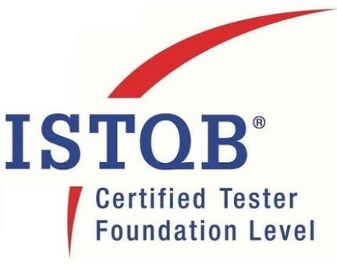 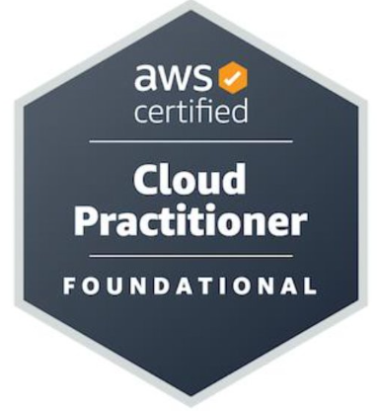 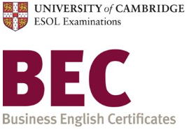 **ARCHANA ANNEPAGA RAJESHWAR**

+91 9885904893 | [archana.ar312@gmail.com](mailto:archana.ar312@gmail.com)

**PRODUCT QUALITY ENGINEER**

**Professional Summary and Objective:**

Quality Focused and Result Oriented professional with **experience** in **Automation testing and manual testing** in **payment, transactions, retail of banking, Enterprise systems and cloud application**. Proven ability with strong expertise in Functional Testing both in manual and automation, Skilled in **QTP, Selenium ,** **Cypress** **and Cucumber, API testing, UI testing, SIT, UAT, Regression, AWS services to test** with **Java** as language automation test frameworks and libraries, design and implementing automation test suites, aspiring to work as Test Lead esteemed organization and ensure high-quality software products are delivered to end users.

* **ISTQB certified, Business English Certified**, **AWS Certified Cloud Practitioner**.
* Excellent communication skills, understand the project from **business and functional perspective**, believe in learning and upgrading skills.
* Awarded as ‘spot’, ‘best team member’, ‘goal oriented’, STAR, ‘Team of the year’, ‘Rookie’ in my tenure.

**Areas of expertise includes:**

* SIT testing, UAT testing, Regression testing, Smoke testing, Performance testing, Security testing.
* Product test management, Defining test strategies/Test plan, End to End Project delivery, Manage Test resources, delivered projects in waterfall, Agile and kanban methods.
* Agile Methodologies, SDLC, STLC, Test Plan, Test Scenario, Test Case Preparation, Defect/Bug Management, Test Documentation, Requirement Traceability Matrix.
* Confluence, Big Bucket (Git), Eclipse, Soap UI, Postman, HP Quality Center, JIRA, Zephyr
* Webservice testing, UI testing, API testing (REST ASSURED), Performance testing (J meter, load runner), enterprise middle ware backend testing.
* SOLID principles, design patterns and integration patterns, OOPS concepts, CORE JAVA
* Selenium Web-driver, QTP, LISA Tool, TestNG, POM, Cucumber, Maven, Jenkins CI/CD, Automation Framework Design, Core Java OOPS, Python, Java Database Connectivity (JDBC), .Net, SQL Query ,UNIX commands, NoSQL (mongo DB, Cassandra), Rest-Assured, TDD, BDD, Postman.
* CICD, Jenkins and Kubernetes, Docker, Automation job scheduler, AWS DevOps.
* AWS services (EC2, S3, ECS, Lambda, CloudWatch, Cloud build)

**PROFESSIONAL EXPERIENCE**

Development Bank of Singapore (DBS), India March 2020 to 2023

**Quality Assurance Specialist**

* Working with Agile teams to assure sprints are delivered with quality as planned to adopt agile methodologies
* Performing UAT test and have walkthrough of results with end Users.
* Ensuring teams to understand best practices to maintain regression test and smoke test suites and to build Jenkins pipelines for Applications.
* Experience with AWS services (S3, CloudWatch).
* Involved in analyzing production issues raised by end users and replicate them in lower environments.
* Collaborate with cross-functional teams to ensure clear communication, engage with scrum teams early during the design phase.
* Handled Test management activities for release and 4 to 6 group of QA members as QA lead.
* Implement and guide to create common functions and design business flow in automation scripts.
* Review automation scripts developed by peers and approve pull requests.
* Developed Regression test suite from the scratch for 3 applications using selenium, Cypress and rest assured.
* Prepare and maintain accurate and detailed test reports, defect logs, and other relevant documentation.
* Participate in Internal and external Audit calls, and implement testing process at department level.
* Conducted and hosted Knowledge transfer session in QA community of 32 members in department.
* Advocated best testing practices.

JP Morgan Chase & co, India September 2016 to March 2020

**Assoc. Application Developer**

* Working in Scrum team as test analyst with strong domain and business expertise.
* Developed automation scripts and contributed to regression suite by using LISA, Selenium, TestNG framework with Java language.
* Collaborated with design and development teams as test lead and delivered new banking architecture projects: Web Application, Event based, Kafka framework, Cloud Gaia application

ADP PVT Ltd, India August 2015 to September2016

**Senior Member Technical**

Recruited to **Automate Insurance service applications** also as QA member of Scrum team to assure sprints are delivered with quality as planned to adopt agile methodologies.

HSBCGlobalTechnology PVT Ltd, India June 2011 to August 2015

**Software Test Engineer**

Played Key role in performing functional testing and delivered major programs of HSBC Net payments and Proficient Automation tester with well-scripting knowledge in **QTP and Selenium to automate HSBC banking application.**

**KEY ROLES AND RESPOSIBILITIES**

* Experience working closely with development and business teams.
* Shows creativity and initiative to improve product test coverage and effectiveness.
* Experience building a QA organization that is responsible for end-to-end validation of a critical system or application.
* A deep understanding of automation testing by leading engineers who can write automation scripts that will aid in automated testing.
* Ability to write, debug and troubleshoot code in programming language ‘Java’.
* Reporting skills, proficient in creating status reports based on automation result.
* Strong knowledge of Agile or Scrum development methodologies.
* Capable of digging into the business needs and translating them into test plans and processes.
* Ability to handle multiple competing priorities in a fast-paced environment.
* Excellent written and verbal communication skills with the ability to present complex technical information in a clear and concise manner to a variety of audiences.

**EDUCATION QUALIFICATION**

**PG Diploma in AI and Machine learning**, 2021 to 2022 – Completed from University of Hyderabad

**Bachelor of Engineering in Computer Science, studied from year 2007 to 2011 (world education system certified)** - Graduated from Jawaharlal Nehru Technological University affiliated college, Hyderabad, India.

With Academic Score 71%