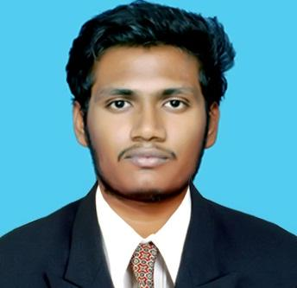

**GANESH.N.M**

# MBA IN FINANCE & LOGISTICS

Address-No-18,Thirumalai Nagar,

Ragavendra Nagar backside,

Sevilimedu post, Kanchipuram.

Mobile-8220678882

e-mail-ganesh24nm@gmail.com

# OBJECTIVE

Looking forward for an opportunity in finance and logistics where I can utilize my knowledge and deliver my full involvement with the organization.

# EDUCATION

|  |  |  |  |  |
| --- | --- | --- | --- | --- |
| **COURSE** | **INSTITUTION** | **BOARD/INSTITUTION** | **PERCENTAGE** | **YEAR**  **OF**  **PASSING** |
| **MBA**  **(Finance & Logistics)** | **Sri**  **Chandrasekharendra**  **Saraswathi Viswa Mahavidyalaya** | **Sri**  **Chandrasekharendra**  **Saraswathi Viswa Mahavidyalaya** | **76.5%** | **2021** |
| **B.COM** |  |  |  |  |
| **(General)** | **SRM University** | **Madras University** | **60%** | **2019** |
| **HSC** | **Swami Vivekananda** |  |  |  |
|  | **Matric Higher**  **Secondary School** | **State Board** | **90%** | **2016** |
| **SSLC** | **Swami Vivekananda** |  |  |  |
|  | **Matric Higher**  **Secondary School** | **State Board** | **84%** | **2014** |

# SKILL SET

* Good in team management and coordination
* Flexible with co-workers and organization
* Ability to grasp things and act on it

# AREA OF INTEREST

* Financial Accounting
* Business Operation
* Logistics management

# TECHNICAL SKILL AND CERTIFICATION

* Completed **TALLY.ERP 9**
* Completed **SAP MM (Basic level)**

# PROJECT

* Study on preference of mobile brand among students
* Study On 3rd Party Logistics

# PERSONAL DETAILS

* Mother’s Name : MAHESWARI C
* Date Of Birth : 29/07/1999
* Gender : Male
* Language : Tamil, English
* Address : No – 18, Thirumalai Nagar, Ragavendhra Nagar backside, Sevilimedu post, kanchipuram.
* Hobbies: playing cricket, swimming, Carrom, badminton, occasionally attending online quizzes.

**EXPERIENCE**

# 

Currently, I am working in an **Indian oil corporation** as an accounts trainee under Apprenticeship Training basis which is an temporary.

# DECLARATION

I hereby declare that the above details are true and correct from my knowledge and

believe.

**Place :** kanchipuram **GANESH** **N** **M**